3GPP TSG-RAN WG1 Meeting #125 R1-2604499
Dalian, CN, May. 18th – 22th, 2026
Agenda item: 10.8.3 - Waveform and frame structure
Title: Discussion on Waveform Design for 6G ISAC
Source: Shanghai Jiao Tong University，NERCDTV
Document for: Discussion/Decision

1. Introduction
During the 108th meeting of RAN, a new SI on 6G Radio was approved. The objectives related to the waveform design for 6GR are as follows [1]:
- Single technology framework based on a stand-alone architecture (Note1) to support the agreed existing and new services, and to satisfy the usage scenarios, requirements, deployment scenarios and design principles with acceptable performance/complexity trade-off, as determined by the RAN requirements in [RP-250810] and [TR38.914], including: [RAN1], [RAN2], [RAN3], [RAN4]
- Aim at using common 6G Radio design, which meets mobile broadband service requirements as high priority, to also meet vertical needs.
- Aim at a harmonized 6G Radio design for TN and NTN, including their integration.
- Physical Layer structure for 6GR,
- Waveforms (OFDM-based) and modulations. 5G NR Waveforms and modulation should be considered for 6GR and is also the benchmark for other potential proposals. [RAN1, RAN4]
- Mobility for 6GR (for all RRC states), including related RRM [RAN2, RAN1, RAN4, RAN3]
- Migration from 5G NR to 6GR as well as interworking and mobility between 5G NR and 6GR:
- 5G-6G Multi-RAT Spectrum Sharing for migration [RAN1, RAN2, RAN4, RAN3]
- Study if any additional migration mechanism is necessary. [RAN] [RAN2, RAN1, RAN3, RAN4]
- Mobility between 5G NR and 6GR [RAN2, RAN3, RAN4]
- Sensing – Studies to be based on use cases and associated requirements, as defined in [TR38.914]
- PHY functions and procedures for sensing technology (e.g., waveform. reference signals, measurement feedback, etc…) [RAN1, RAN4]
- Evaluate sensing performance and if necessary, extend channel modelling, for the selected use cases [RAN1]
- Aspects of integration with communication services [RAN1]

In current 5G NR systems, OFDM has been adopted as the baseline waveform due to its maturity and ease of integration with MIMO. This choice aligns well with the 6GR objectives of supporting a single technology framework and enabling smooth migration from 5G NR as outlined in (1) and (7). The well-established implementation chain and compatibility with existing NR numerologies make OFDM a natural reference point for future waveform discussions.
However, when considering the broader 6GR requirements, including high mobility in (4), harmonized TN/NTN operation (1.j), and sensing capabilities in (9), certain limitations of OFDM become apparent. Its orthogonality is highly sensitive to Doppler spread, leading to performance degradation in high-speed terrestrial or satellite channels. Moreover, multi-carrier OFDM signals for sensing exhibit elevated sidelobe levels in their autocorrelation function, which degrades detection reliability, and restricts multi-target resolution.
To address these limitations while maintaining compatibility with the OFDM-based framework of 5G NR, affine frequency division multiplexing (AFDM) has recently emerged as a promising candidate waveform for 6G integrated sensing and communication (ISAC). By mapping information symbols onto chirp-based subcarriers via the discrete affine Fourier transform (DAFT), AFDM enables each subcarrier to span the entire system bandwidth and achieve inherent robustness against both delay and Doppler spreads. This property is particularly advantageous for high-mobility scenarios in (4) and TN/NTN integration in (1.j). In addition, the full-bandwidth occupation of each subcarrier allows AFDM to achieve high sensing accuracy with a reduced number of subcarriers, thereby improving sensing efficiency.
As demonstrated in [2], AFDM can achieve high-accuracy ranging even with a single subcarrier, significantly reducing resource overhead compared to OFDM-based sensing schemes. Furthermore, AFDM exhibits simular PAPR characteristics to OFDM with flexible parameter configurations [3]. Its signal structure also remains compatible with the existing OFDM processing chain (e.g., FFT/IFFT reuse), which ensures low implementation complexity, minimal hardware impact, flexible spectrum sharing ability with OFDM, and a smooth migration path, in line with the objectives in (7).
When considering waveform enhancements for 6G ISAC based on CP-OFDM and DFT-s-OFDM, the underlying sequence properties of reference signals (RS) (e.g., PAPR, PSLR, and auto-/cross-correlation functions) constitute the foundation for robust synchronization, accurate channel estimation, and high-resolution target sensing. Consequently, advanced sequence design and optimization are imperative to fulfill the demanding requirements of emerging ISAC applications.
In this contribution, we present our perspectives on waveform enhancement based on CP-OFDM and new waveform candidates (with a particular focus on AFDM) for 6G ISAC.

2. Waveform Enhancement for 6G ISAC
It has been agreed in RAN1 that the study of sensing RS for ISAC should start from reusing existing communication RS, and then progress to enhanced and dedicated sensing RS. Following this principle, the baseline candidates for dual-functional waveform design are the communication RS already specified in 5G NR, such as SRS, CSI-RS, and PRS.
Prioritizing the reuse of communication RS offers profound systemic advantages. It inherently minimizes the sensing overhead, which can otherwise be substantial due to the need for time accumulation and multi-directional beam scanning, while seamlessly preserving overall spectral efficiency. The technical rationale for this reuse lies in their inherent mathematical properties: as demonstrated in [4], the communication RS requirement of constant modulus in the frequency domain is mathematically equivalent to the sensing RS requirement of perfect periodic auto-correlation in the time domain. This fundamental equivalence provides a solid foundation for ISAC design without necessitating structural changes to the existing framework.
However, practical ISAC deployment introduces new challenges that direct reuse alone cannot fully resolve. In long-range coverage scenarios (e.g., Unmanned Aerial Vehicle (UAV) detection), extremely high transmit power is demanded to overcome path loss. In such high-power scenarios, the Peak-to-Average Power Ratio (PAPR) of the baseline RS becomes a critical bottleneck, severely degrading Power Amplifier (PA) efficiency and limiting the maximum sensing range. Furthermore, issues regarding self-interference resilience for mono-static operation and limited unambiguous range due to large comb sizes must also be addressed.
Therefore, it is imperative to introduce targeted enhancements to the existing RS. To overcome the PAPR bottleneck and other sensing-specific limitations, enhancements can be approached from two main directions. The first direction involves optimizing the tunable parameters of existing reference sequences (e.g., ZC sequence root indices) to minimize time-domain envelope fluctuations. The second direction explores advanced non-sequence design methods, such as utilizing low-PAPR modulation schemes and non-linear frequency modulation (NLFM), to decouple sidelobe suppression from PAPR degradation.
Proposal 1: The design of sensing RS and waveform enhancements for 6G ISAC shall take the reuse of existing communication RS (e.g., SRS, CSI-RS, PRS) as the baseline. RAN1 is encouraged to investigate targeted enhancements from both sequence parameter optimization and advanced signal/modulation designs to address sensing-specific requirements such as PAPR reduction, self-interference resilience, and range ambiguity.

2.1 Impact of Tunable Sequence Parameters on PAPR
To systematically address the PAPR degradation in pulse-based ISAC waveforms, we formulate a mathematical model based on the DFT-s-OFDM signal generation chain. Let $N$ denote the total number of subcarriers, $M$ denote the number of allocated active subcarriers, and $N_{ZC}$ denote the length of the sensing reference sequence.
The discrete-time baseband reference signal, primarily utilizing a ZC sequence with root index $u$, is defined as:
$$z_{u}\left[n\right]=\exp\left(-j\frac{πun(n+1)}{N_{ZC}}\right)$$
To create a pulse-based waveform that mitigates self-interference, zero-padding is applied in the time domain. The extended time-domain sequence $x[n]$ of length $M$ is formed by appending zeros:
$$x\left[n\right]=\left\{\begin{aligned}z_{u}\left[n\right], 0≤n≤N_{ZC}-1 \\ 0, { N}_{ZC}≤n≤M-1 \end{aligned}\right.$$
The sequence $x\left[n\right]$ is then transformed to the frequency domain via an M-point DFT:
$$X\left[k\right]=\frac{1}{\sqrt{M}}\sum_{n=0}^{M-1}{x\left[n\right]\exp\left(-j\frac{2πnk}{M}\right),k=0,1,….,M-1}$$
Following frequency-domain subcarrier mapping (allocating $M$ symbols to $N$ subcarriers with guard bands) and an $N$-point IFFT, the final oversampled continuous-time-equivalent signal s[n] is generated. The PAPR is mathematically defined as:

$$PAPR=\frac{\max_{0≤n≤N-1}|s[n]|^{2}}{\frac{1}{N}\sum_{n=0}^{N-1}{|s[n]|^{2}}}$$
While $z_{u}\left[n\right]$ is strictly constant modulus, the zero-padding operations in time/frequency domain fundamentally alter the signal envelope.
The theoretical impact of key tunable parameters on PAPR is systematically analyzed as follows:
1) Root Index:
The root index $u$ strictly dictates the instantaneous phase derivative of the ZC sequence. The phase difference between adjacent samples is:
$$∆∅\left[n\right]=-\frac{πu}{N_{ZC}}(2n+1)$$
When $u$ is large and coprime to $N_{ZC}$, the sequence experiences aggressive phase wraps. Upon passing through the band-limited frequency mapping, these sharp time-domain phase transitions cannot be faithfully reconstructed due to the truncation of high-frequency harmonics. According to Fourier theory, this abrupt phase variation combined with band-limiting induces the Gibbs phenomenon, producing severe amplitude overshoots at the phase jump locations. Minimizing PAPR thus mathematically requires optimizing to constrain the maximum phase derivative within the Nyquist bandwidth limits.
2) System Bandwidth Occupancy (M/N):
The bandwidth occupancy ratio (M/N) dictates the density of the frequency-domain allocation. The zero-padding from M to N in the frequency domain corresponds to an ideal low-pass filtering operation. In the time domain, the output signal s[m] is equivalent to the circular convolution of the upsampled sequence with the Dirichlet kernel:
$$s\left[m\right]=x\left[m\right]⊛D_{M}\left[m\right], where D_{M}\left[m\right]=\frac{sin⁡(πmM/N)}{M sin⁡(πm/N)}$$
Mathematically, a low bandwidth occupancy ($M≪N$) significantly narrows the rectangular window in the frequency domain, which in turn stretches the mainlobe and amplifies the side-ripples of the Dirichlet kernel $D_{M}\left[m\right]$ in the time domain. Convolving the constant-modulus sequence with this highly oscillatory kernel induces severe Fresnel ripples. To approach the theoretical PAPR limit of 0 dB, must approach 1, forcing $D_{M}\left[m\right]$ to approximate a Dirac delta function.
3) Time-Domain Duty Cycle ($N_{ZC}$/M):
To formulate a sensing gap for self-interference avoidance, a duty cycle $ρ=N_{ZC}$/M is configured via time-domain zero-padding. Mathematically, this equates to applying a rectangular window w[n] to the sequence, which manifests as a circular convolution with a discrete sinc kernel W[k] in the frequency domain:
$$X_{trunc}\left[k\right]=X\left[k\right]⊛W[k]$$
A smaller $ρ$ inherently broadens the mainlobe of W[k] and intensifies spectral leakage. When this spectrally expanded signal $X_{trunc}\left[k\right]$ is subjected to strict frequency-domain band-limiting to satisfy Out-of-Band Emission (OOBE) constraints, significant high-frequency energy is abruptly truncated. According to Fourier theory, the inverse transform of this incomplete spectrum inevitably triggers the Gibbs phenomenon. Consequently, time-domain pulse compression fundamentally contradicts the constant-modulus condition, leading to severe PAPR deterioration.
Observation 1: To support long-range sensing and overcome self-interference, pulse-based waveforms require reference sequences with strict low-PAPR properties. However, operations such as time/frequency-domain zero-padding and truncation fundamentally disrupt the constant modulus property of ZC sequences, leading to severe PAPR degradation.
Proposal 2: RAN1 to study the joint mathematical optimization of pulse-based waveform parameters, specifically the sequence root index, duty cycle, bandwidth occupancy, to theoretically bounds the worst-case PAPR while satisfying the high-power requirements of ISAC deployments.

2.2 Advanced Signal and Modulation Designs for PAPR Reduction
While optimizing the parameters of existing sequences provides a baseline for PAPR reduction, addressing the stringent coverage requirements of 6G ISAC necessitates further signal-level enhancements. Therefore, we also support the following directions.
Recent RAN1 discussions have identified several advanced modulation and sequence generation techniques proposed to overcome the physical limitations of conventional sequences.
1) Non-Linear Frequency Modulation (NLFM) (R1-2602759)
To decouple sidelobe suppression from PAPR degradation, ZTE proposed the use of non-linear frequency modulation (NLFM) [4]. Unlike traditional frequency-domain windowing which destroys the constant modulus property, the NLFM signal maintains a constant amplitude $A$, with the complex baseband representation expressed as
$$s\left(t\right)=A\exp\left(j2π\int_{0}^{t}{f\left(τ\right)dτ}\right),$$
where the instantaneous frequency $f\left(τ\right)$ is a non-linear function of time. By tailoring the frequency sweeping rate, the energy density in the frequency domain can be controlled to achieve an equivalent windowing effect for sidelobe suppression without inducing amplitude fluctuations.
2) $π/2$-BPSK Modulation (R1-2603081)
From a modulation perspective, DCM suggested utilizing $π/2$-BPSK instead of conventional QPSK for pseudo-random (PN) sequences [5]. The symbol sequence $x_{n}$ is generated with a deterministic phase rotation:
$$x_{n}=\exp\left(j\left(θ_{n-1}+\frac{π}{2}+b_{n}π\right)\right),$$
where $b_{n}∈\{0,1\}$ represents the data bits. This $π/2$ shift between consecutive symbols ensures that the signal trajectory avoids the origin in the complex plane, effectively minimizing zero-crossings and reducing the PAPR after pulse shaping.
3) FMCW-like Sequence (R1-2603032)
To mitigate the aliasing and PAPR degradation caused by the truncation of discretely sampled signals, Qualcomm proposed an FMCW-like sequence (E-ZC) [6]. By introducing an expansion factor $M$ to increase the sampling rate, the discrete phase of the enhanced sequence is defined as
$$ϕ_{k}=π\frac{u}{N}{\left(\frac{k}{M}\right)}^{2}, k=0,1,…,MN-1.$$
This approach approximates the continuous-time linear frequency modulation (LFM) behavior more closely. The increased granularity in the phase domain eliminates edge aliasing during spectral truncation, resulting in a more stable time-domain envelope and lower PAPR compared to conventional discrete ZC sequences.
Based on the industry consensus to explore diverse PAPR optimization routes to ensure sensing coverage, we have the following proposal:
Proposal 3: RAN1 to study and evaluate advanced PAPR reduction techniques for ISAC reference signals, including but not limited to non-linear frequency modulation (NLFM), enhanced modulation schemes (e.g., $π/2$-BPSK), and oversampled FMCW-like sequences.

3. New Waveform for 6G ISAC
The selection of the physical layer waveform is a fundamental decision impacting performance, complexity, and ecosystem migration. Given the maturity of the existing 5G NR infrastructure and the extensive industry experience with OFDM, it is reasonable to consider an OFDM-based waveform as the baseline candidate for 6G systems. OFDM offers well-understood implementation, straightforward integration with MIMO, and a high degree of scalability across diverse deployment scenarios. Maintaining OFDM as the basic waveform ensures smooth migration from NR, facilitates re-use of current hardware and software processing blocks (e.g., FFT/IFFT modules, numerology, frame structure), and reduces the risks associated with large-scale standard transitions.
At the same time, it is noted that ISAC has not yet been widely deployed in practical cellular systems, and its performance requirements and design trade-offs are still under active investigation. In addition to ISAC, emerging 6G scenarios such as high-mobility environments and NTN operation introduce new challenges that may not be fully addressed by OFDM alone. Therefore, it is of interest to explore whether alternative waveform designs can provide potential benefits, particularly in delay-Doppler channels and sensing-related functionalities, while maintaining compatibility with the existing framework.
To balance performance exploration and migration efficiency, it is beneficial to study additional waveform candidates that are structurally compatible with OFDM. Such waveforms should enable reuse of key NR signal processing components, preserve compatibility with established numerology and frame structures, and at the same time offer potential enhancements in robustness to delay and Doppler effects, as well as improved support for emerging ISAC use cases.
Proposal 4: RAN1 to study additional waveform candidate(s) (e.g., AFDM) for 6G that remain structurally compatible with OFDM, enabling reuse of 5G NR/6G ecosystem components, while providing potential performance enhancements for ISAC and other challenging propagation scenarios.

3.1 Waveform Candidate: AFDM
AFDM is a multicarrier waveform based on the discrete affine Fourier transform (DAFT). As illustrated in Figure 1, its transmitter and receiver architectures revolve around a central IFFT/FFT processing block, augmented by diagonal matrix multiplications preceding the IFFT at the transmitter and succeeding the FFT at the receiver. These matrices are defined by two affine parameters, $c_{1}$ and $c_{2}$. This architecture makes AFDM highly compatible with the existing NR framework and enables each subcarrier to occupy the entire bandwidth.
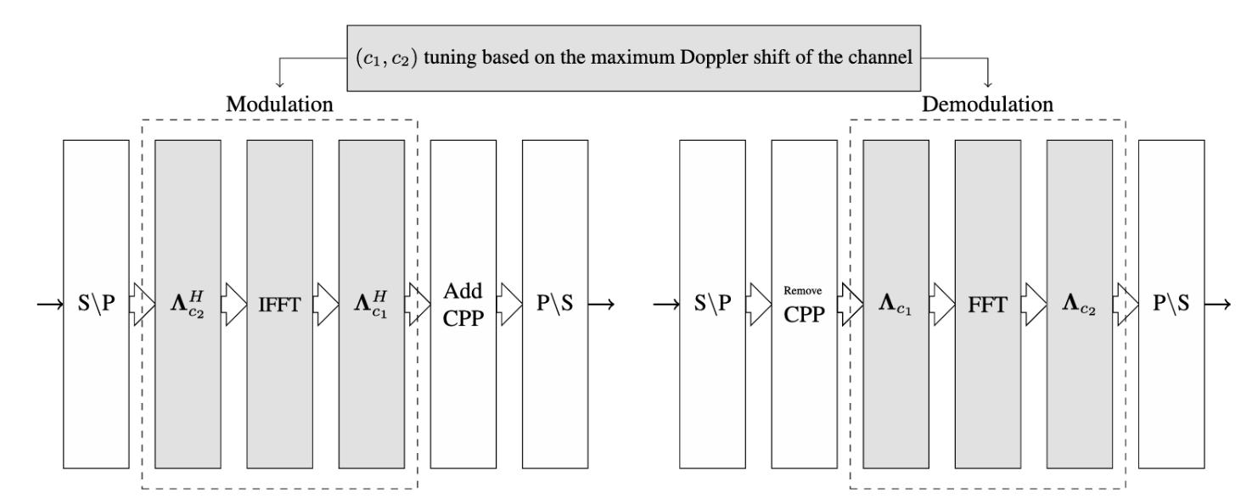
Figure 1: The AFDM modulation and demodulation block diagram

3.1.1 Compatibility with 5G Systems
As a promising candidate waveform for 6G ISAC, AFDM exhibits profound systemic compatibility with the existing 5G ecosystem, enabling a smooth migration path. This compatibility is primarily demonstrated through its capability to reuse existing frame structures, its controllable hardware complexity, its inherent mathematical alignment with the OFDM architecture, and its capability in dynamic spectrum sharing with OFDM.
1) Frame Structure Reuse
AFDM and CP-OFDM operate on the resource grids in the same manner, as shown in Figure 2. Therefore, AFDM can seamlessly inherit the 5G NR scalable numerology, including the flexible subcarrier spacing ($Δ f = 2^{μ}× 15$ kHz) configurations. This inherent compatibility ensures that the core physical layer definitions, such as sampling rates, baseband bandwidth, and resource block dimensions, are preserved.
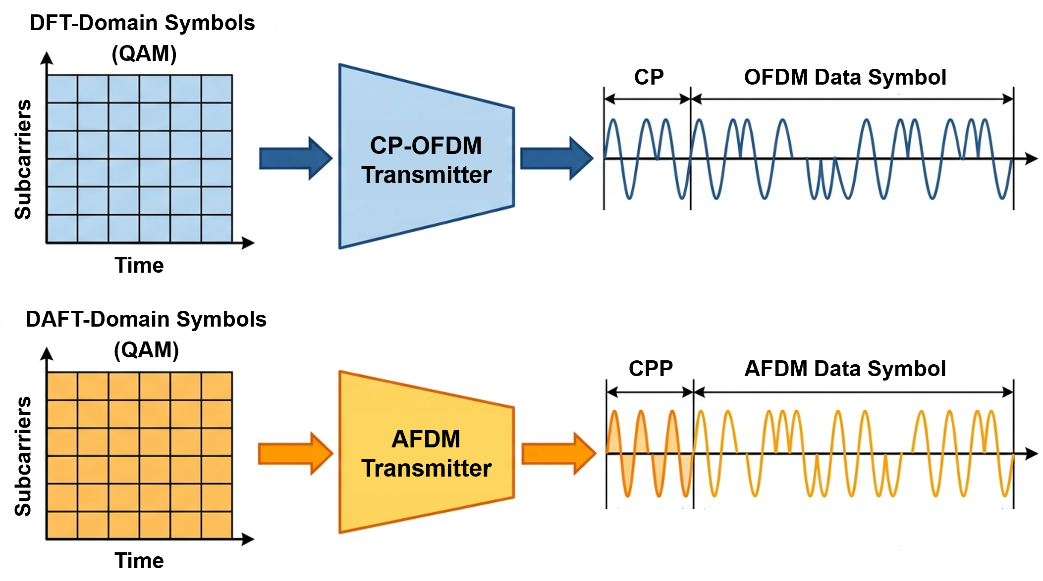
Figure 2: Similarities between AFDM and CP-OFDM in PHY layer
Furthermore, the chirp-periodic prefix (CPP) insertion process, which is similar to the cyclic prefix (CP) insertion in CP-OFDM systems, is also retained in the AFDM system, as shown in Figure 2. Additionally, the CPP becomes mathematically equivalent to the standard CP when specific AFDM parameters are applied. Since AFDM maintains conventional time-domain frame structures, its adoption leaves the higher-layer frame structures and MAC-layer timing relationships unaffected. Such a high degree of structural alignment enables AFDM to be integrated smoothly as a transparent, alternative waveform configuration within the CP-OFDM framework.
2) Low-Cost Hardware Reuse
The core computational engine of AFDM remains the highly optimized $O\left(N\log{N}\right)$ FFT/IFFT hardware accelerators. The additional pre- and post-chirp multiplications only introduce $O\left(N\right)$ linear complexity, since the pre-chirp multiplication can be considered as a precoding operation and post-chirp multiplication can be implemented through phase rotations, as illustrated in Figure 3. In baseband application-specific integrated circuit (ASIC) implementations, these pure phase rotations can be highly optimized via coordinate rotation digital computers (CORDIC) or look-up tables (LUTs), introducing negligible silicon area and power overhead.
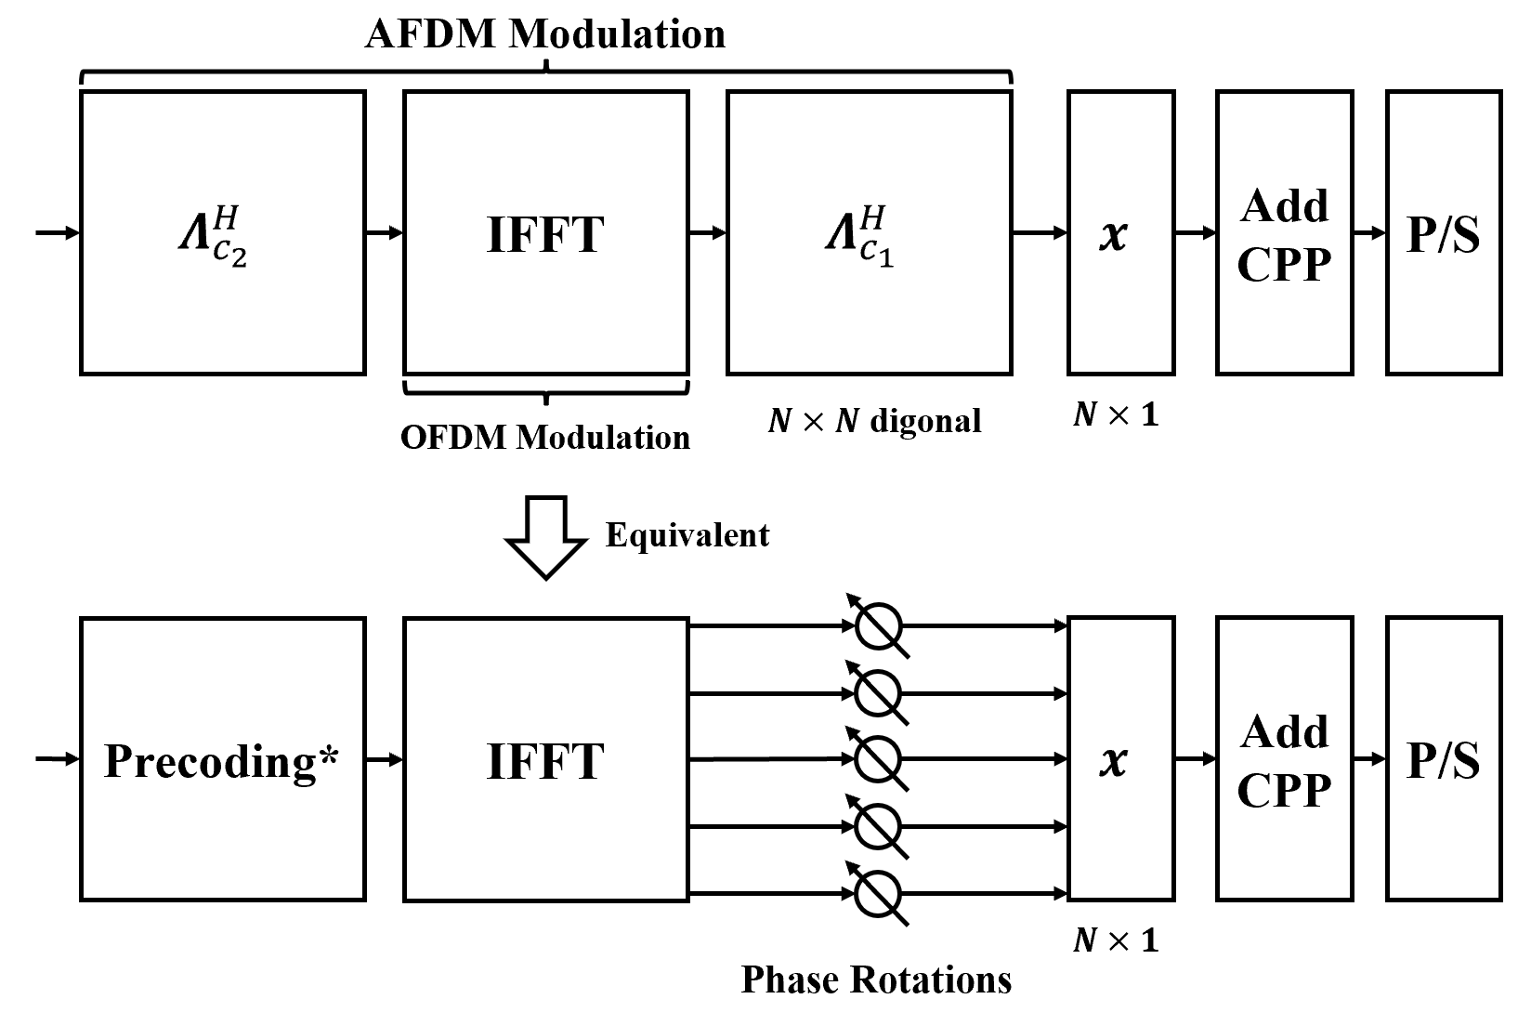
Figure 3: Equivalent representations of chirp multiplications of AFDM
Furthermore, by maintaining PAPR characteristics comparable to those of CP-OFDM, AFDM enables the direct reuse of existing power amplifier (PA) designs without requiring additional power back-off.
3) Mathematical Alignment
The AFDM systems can be backward compatible with the current OFDM systems. By setting $c_{1}$ and $c_{2}$ to 0, the AFDM systems become the OFDM systems.
Furthermore, when the chirp parameter $c_{1}$ satisfies certain conditions, the AFDM modulation can be expressed as a DFT-based precoding stage followed by an IDFT operation, which aligns with the modulation structure of DFT-s-OFDM, as illustrated in Figure 4 [7]. This structural alignment indicates that AFDM is inherently suitable for uplink transmission, as it can be implemented using the existing 5G NR uplink processing chain originally designed for DFT-s-OFDM. Consequently, the DFT-based modulation and demodulation methods for AFDM not only achieve backward compatibility with OFDM/DFT-s-OFDM systems, but also retain the flexible pre-chirp parameter $c_{2}$, which does not exist in conventional DFT-s-OFDM. Unlike conventional DFT-s-OFDM, this extra degree of freedom in AFDM can be exploited for further signal optimization, such as PAPR reduction, which will be detailed in Section 4.3.
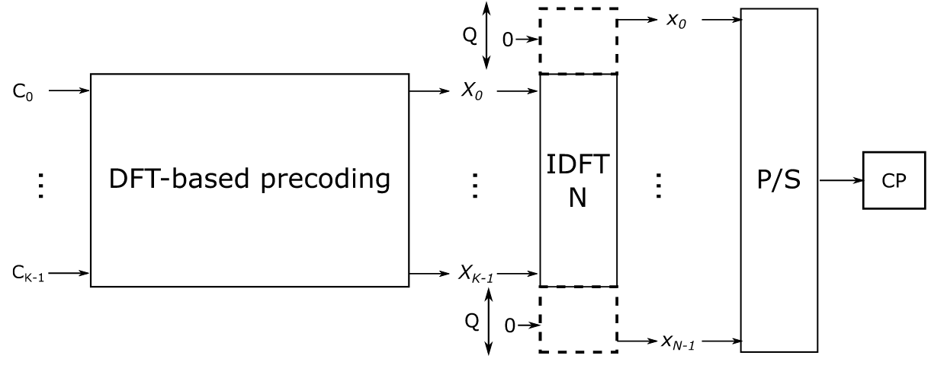
Figure 4: AFDM modulation as DFT precoded OFDM
4) Flexible Spectrum Sharing
Beyond the aforementioned structural alignment, AFDM supports orthogonal coexistence with OFDM systems within a shared resource grid, facilitating a highly flexible and interference-free migration path. Theoretical analysis demonstrates that by properly configuring the AFDM chirp parameter, AFDM signals exhibit a sparse, comb-like representation in the frequency domain, while OFDM signals symmetrically demonstrate sparsity in the affine domain. This mutual domain sparsity enables the time-frequency resources to be systematically partitioned into mutually disjoint residue classes, as shown in Figure 5 [8].
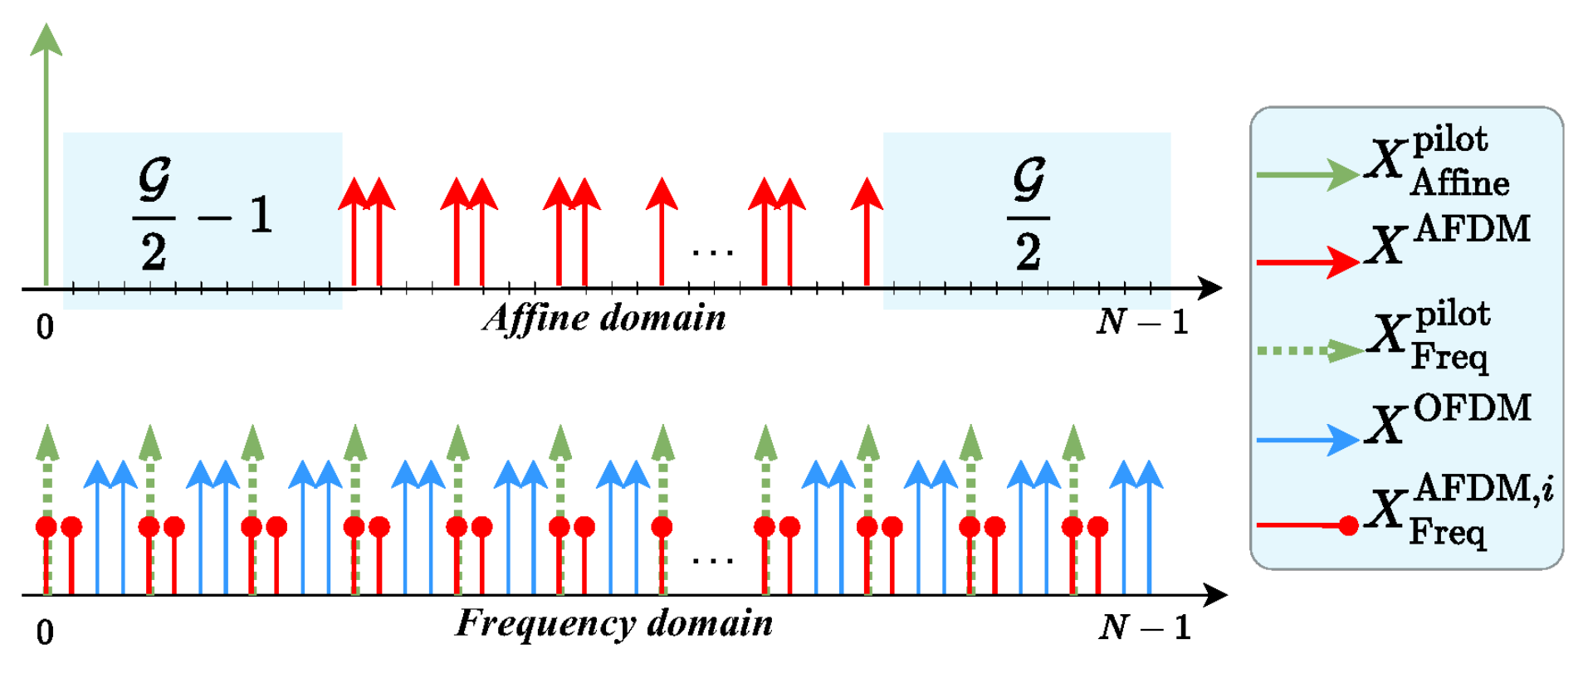
Figure 5: Pilot/data placement for AFDM-OFDM spectrum sharing
Consequently, a base station can flexibly multiplex AFDM and OFDM symbols onto these non-overlapping index sets, guaranteeing orthogonality by construction without inducing destructive mutual interference. This physical-level waveform multiplexing allows the network to concurrently serve OFDM devices (e.g., static or low-mobility users) and AFDM-capable devices (e.g., high-mobility users) over the same allocated bandwidth, facilitating the flexible allocation of both waveforms and seamlessly accommodating the heterogeneous deployment requirements of 6G.

3.1.2 Subcarrier Characteristics
Beyond its structural compatibility, the physical properties of AFDM are fundamentally different from OFDM. The DAFT basis function contains a quadratic phase term ($e^{j2πc_{1}n^{2}}$) dependent on the time index $n$. This term gives each subcarrier a linearly varying instantaneous frequency, which is the defining characteristic of a chirp signal. As a result, unlike a static OFDM subcarrier, each AFDM subcarrier actively sweeps across the entire operational bandwidth during a symbol period, as illustrated in Figure 6.
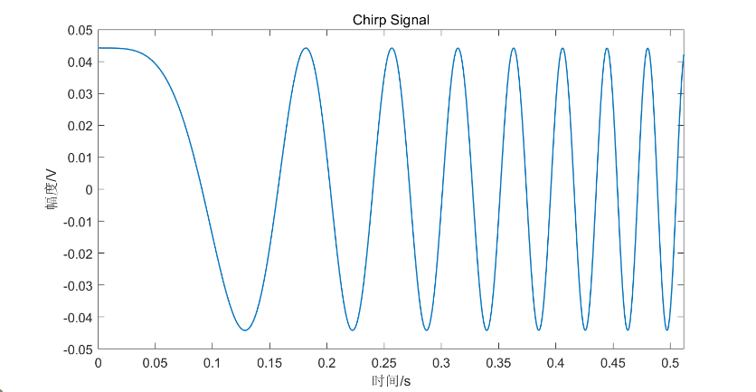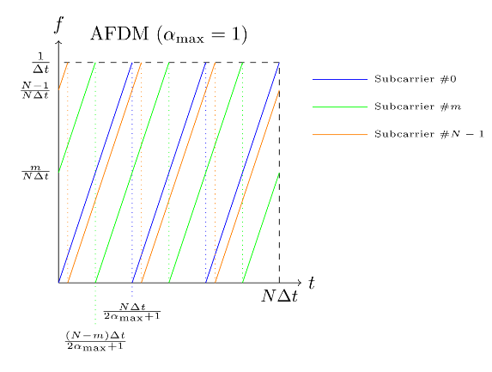
(a) Chirp characteristic of an AFDM subcarrier (b) time-frequency representation of AFDM subcarriers
Figure 6: Time-frequency characteristics of AFDM subcarriers
This inherent wideband characteristic of an individual AFDM subcarrier offers substantial benefits for ISAC applications. As radar range resolution is inversely proportional to the signal bandwidth, a single AFDM subcarrier can provide excellent range resolution on its own. This enables high-precision sensing with minimal resource overhead, thereby rendering it well-suited for robust ISAC implementations.
Observation 2: The structural compatibility of AFDM with OFDM-based systems, which arises from its implementation using existing IFFT/FFT blocks with low cost and flexible spectrum sharing capability with OFDM, combined with the inherent wideband nature of its individual chirp subcarriers, makes it a compelling candidate for ISAC. It offers the potential for high-resolution sensing with minimal hardware modification to the NR framework.

3.2 AFDM Waveform Performance Analysis
While AFDM already demonstrates promising properties as a candidate waveform for 6G ISAC systems, further optimization of its design parameters (including the post-chirp parameter $c_{1}$ and the pre-chirp parameter $c_{2}$ ) can significantly enhance its performance across a wide range of deployment scenarios.
In our view, parameter optimization should be guided by the following aspects at least:
- High-efficiency sensing capability: Configure parameters to achieve sharp matched filter responses and high delay-Doppler resolution, enabling accurate ranging and velocity estimation with minimal sensing-specific resource overhead.
- Robustness to high-mobility: Optimize $c_{1}$ and $c_{2}$ to maintain orthogonality and minimize inter-symbol interference in the presence of large Doppler and delay spreads, as encountered in high-mobility terrestrial scenarios and non-terrestrial networks.
- Low Peak-to-Average Power Ratio (PAPR): Select parameter combinations that minimize envelope fluctuations in the time-domain signal, thereby improving power amplifier efficiency, particularly for power-limited devices.
- Maximized compatibility with OFDM: Ensure that AFDM parameter settings maintain alignment with existing NR numerology, FFT/IFFT sizes, and frame structures, to the greatest extent possible. This facilitates coexistence, spectrum sharing, and smooth migration from current OFDM-based systems.
Proposal 5: RAN1 to investigate AFDM as a candidate waveform for 6G ISAC systems, evaluating its parameter optimization towards high-efficiency sensing, high-mobility robustness, low PAPR, and backward compatibility with OFDM-based architectures.

3.2.1 Sensing Performance in ISAC Scenarios
Building on the robust communication performance of AFDM in high-mobility environments, this subsection evaluates its sensing performance in ISAC scenarios. To demonstrate AFDM’s efficacy in achieving high-precision sensing with reduced pilot overhead while facilitating reliable multi-target resolution, autocorrelation function results are presented for AFDM versus OFDM under the equivalent pilot overhead.
For simplicity, the simulation employs a 256-point FFT and a 30 kHz subcarrier spacing. However, the configuration can be further extended to the 5G NR standard with a larger FFT size. Specifically, in Figure 7(a), AFDM utilizes a single pilot with 31 guard intervals, whereas OFDM deploys 32 uniformly distributed pilots across all subcarriers. For a fair comparison, the number of subcarriers occupied for sensing and total pilot power allocated to AFDM are equal to those of OFDM, such that both schemes operate under the same energy budget.
Figure 7(a) reveals that AFDM achieves superior sidelobe suppression attributable to its inherent chirp-modulated subcarrier structure, thereby enabling full bandwidth utilization and high-resolution sensing via a single subcarrier. In contrast, the autocorrelation function of OFDM exhibits multiple peaks, where the horizontal spacing between adjacent peaks corresponds to the maximum unambiguous range. When the target distance exceeds this range, the correlation peaks of the echo signal repeat periodically, causing range ambiguity and parameter estimation errors. In this case, the maximum unambiguous range of AFDM is four times that of OFDM.
Moreover, the maximum unambiguous range of OFDM depends on the pilot spacing—a smaller pilot interval (i.e., denser pilots) leads to a larger maximum unambiguous range. As shown in Figure 7(b), when OFDM employs 64 uniformly spaced pilots, the distance between adjacent peaks increases, resulting in an extended maximum unambiguous range but at the cost of higher pilot overhead. Therefore, to achieve the same maximum unambiguous range, AFDM requires significantly lower pilot overhead than OFDM.
For a more comprehensive comparison, Figure 7(c) presents the autocorrelation function of single-pilot AFDM versus OFDM with 32 randomly (non-uniformly) distributed pilots. As observed, although the non-uniform pilot spacing resolves range ambiguity, it results in an elevated, noise-like sidelobe floor. This high sidelobe level limits the sensing performance, particularly for weak target detection.
(a) AFDM single pilot vs OFDM 32 pilots (b) AFDM single pilot vs OFDM 64 pilots
(c) AFDM single pilot vs non-uniform OFDM 32 pilots
Figure 7: Periodic autocorrelation functions comparison of AFDM and OFDM
To further evaluate the sensing performance in a dynamic multi-dimensional domain, the comparison of the 2D Range-Doppler Map (RDM) generated via the 2D-FFT algorithm for both AFDM and OFDM waveforms is showed in Figure 8. The simulation is configured with 1024 subcarriers, a subcarrier spacing of 120 kHz, and a carrier frequency of 30 GHz. A target is simulated at an actual range of 73 m and a relative velocity of 57 m/s under an SNR of 0 dB. In this setup, AFDM utilizes a single pilot positioned at the first subcarrier surrounded by 30 guard intervals, whereas OFDM employs 32 uniformly spaced pilots.
As depicted in Figure 8, the OFDM RDM exhibits multiple peaks along the range dimension, which may introduce ambiguity during target detection. In contrast, the AFDM RDM presents a primary peak corresponding to the target's simulated range and velocity coordinates. These observations indicate that, under this specific simulation setup, AFDM has the potential to mitigate range ambiguity and support target detection with a comparatively lower pilot overhead than the evaluated OFDM configuration.
Figure 8: 2D-FFT RDM spectrum of AFDM and OFDM
At the receiver, the MUSIC algorithm is employed for target parameter estimation and detection. In the simulation, the FFT size is set to 512. The AFDM waveform utilizes a single pilot symbol with 31 zero guard intervals placed symmetrically on both sides, whereas the OFDM waveform deploys 32 uniformly distributed pilots across all subcarriers. When the target is located at a range of 80 m and a velocity of 15 m/s, the corresponding MUSIC spectra for range and velocity estimation are obtained, as illustrated in Figure 9.
unambiguous range
Figure 9: MUSIC range/velocity spectrum of AFDM and OFDM
As observed, with a relatively small pilot overhead, the OFDM-based MUSIC range spectrum exhibits multiple peaks, resulting in range ambiguity and interference to peak detection. In contrast, the AFDM-based spectrum presents a sharper main lobe and lower sidelobe levels, indicating superior range detection performance.
Observation 3: Compared with OFDM, AFDM can achieve a larger maximum unambiguous range with lower pilot overhead, thereby extending sensing range, improving target resolution capability and spectral efficiency.

3.2.2 BER Performance in High-Mobility Scenarios
We conduct a comparative simulation of the communication BER performance between OFDM and AFDM to assess the viability of AFDM. The parameters are set according to typical 5G NR configurations, including an FFT size of 2048, a carrier frequency of 3 GHz, a bandwidth of 30 MHz, and QPSK baseband modulation. For the channel model, the Tapped Delay Line-D (TDL-D) specified in 3GPP TR 38.900 (Release 15) is adopted. Since IMT-2030 defines the 6G mobility requirement to support speeds from 500 km/h to 1000 km/h, normalized Doppler shifts of 0.02, 0.06, 0.1, and 0.2 are considered, corresponding to speeds ranging from 100 km/h to 1000 km/h. A linear minimum mean square error (LMMSE) equalizer is applied for symbol detection in both waveforms. The simulation is performed under SNR conditions from 0 dB to 12 dB, and the results are illustrated as follows
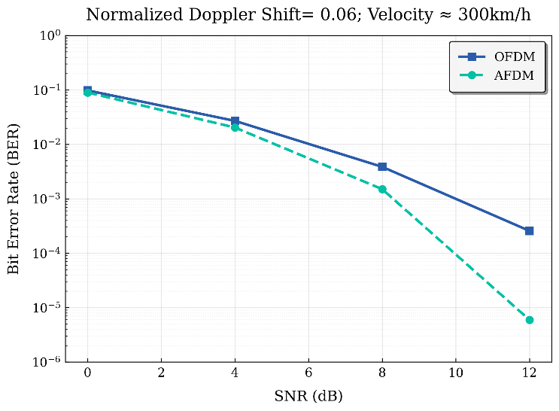
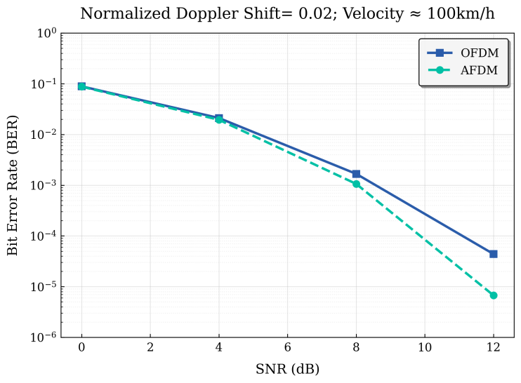
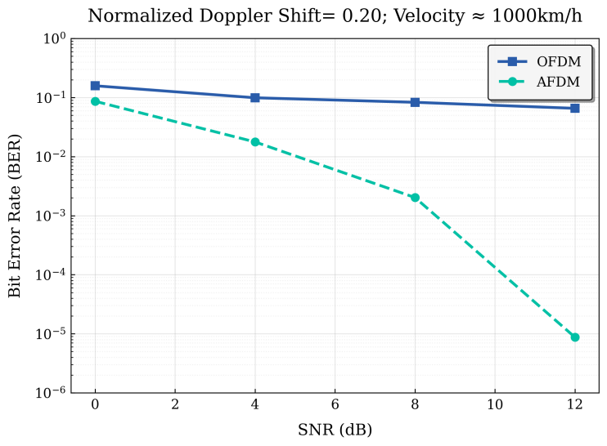
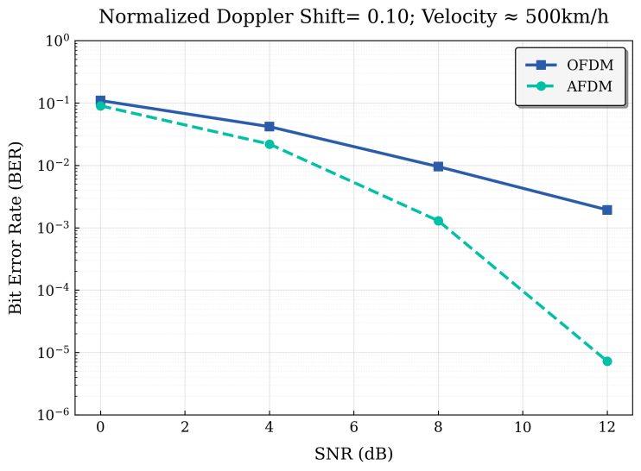
Figure 10 BER performance comparison of AFDM and OFDM
Figure 10 illustrates that under identical conditions, AFDM maintains stable BER performance across different Doppler shifts, while OFDM exhibits a significant degradation in BER as the velocity increases. This demonstrates the superior Doppler resilience of AFDM, which enables more reliability in high-mobility communication scenarios compared to OFDM.
Observation 4: In TDL-D channels, AFDM demonstrates a gain of nearly 2 dB over OFDM at 300 km/h and more than 4 dB at 500 km/h for a BER of 1e-3, with an even more pronounced advantage at the higher velocity of 1000 km/h.

3.2.3 PAPR reduction for AFDM via pre-chirp parameters
High PAPR is a well-known challenge for multicarrier waveforms, which also applies to AFDM. A high PAPR requires a larger power amplifier back-off, which limits the transmitter’s power efficiency and is a critical issue for power-constrained devices. Correspondingly, a lower PAPR implies higher power efficiency, enabling the transmitter to send the waveform over a greater distance, which in turn expands its sensing coverage area. Improving energy efficiency is one of the key design principles for the 6G system.
Fortunately, the structure of AFDM provides inherent flexibility to address this issue, ,compared to conventional low-PAPR waveforms like DFT-s-OFDM. The AFDM modulation is based on the DAFT, which is defined by a post-chirp parameter and a pre-chirp parameter. While the value of $c_{1}$ is constrained by the maximum Doppler shift to ensure full diversity, the selection of $c_{2}$ is much more flexible. This degree of freedom creates a unique opportunity for reducing PAPR, particularly for uplink transmission, since AFDM preserves the DFT-based modulation structure while offering additional design flexibility beyond conventional DFT-s-OFDM.
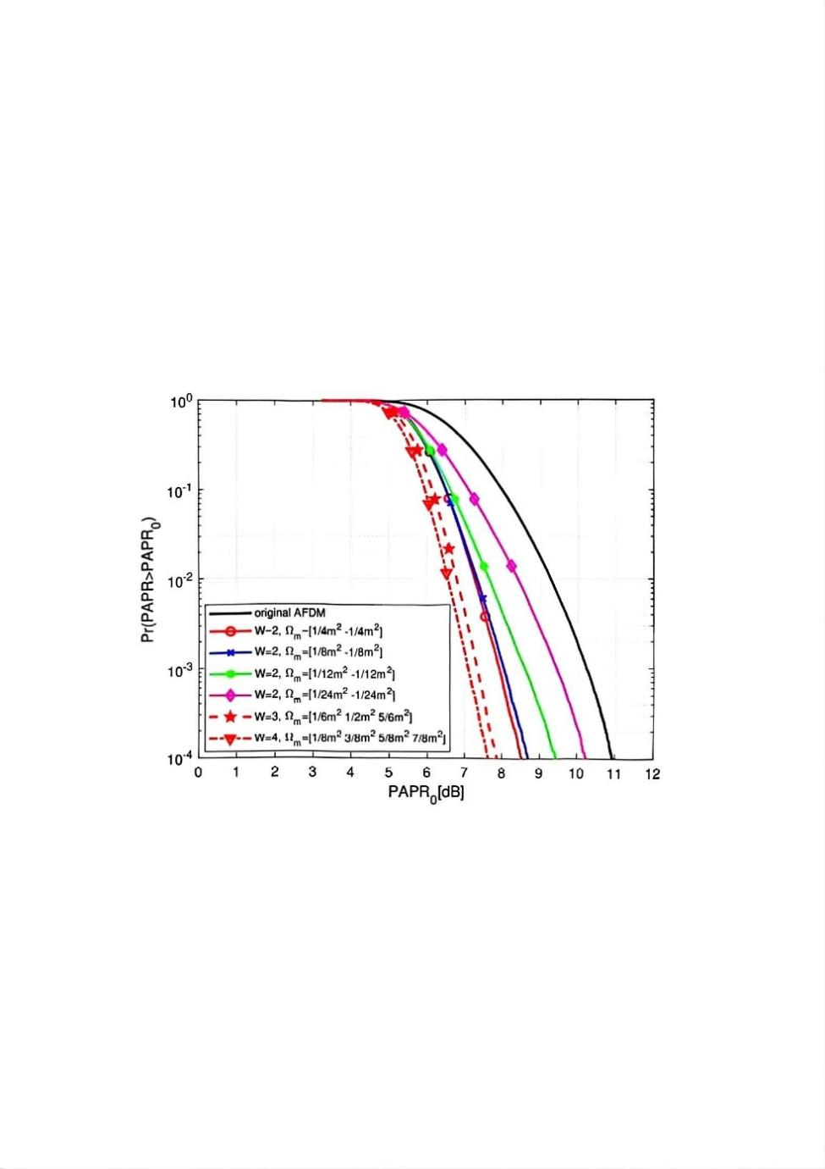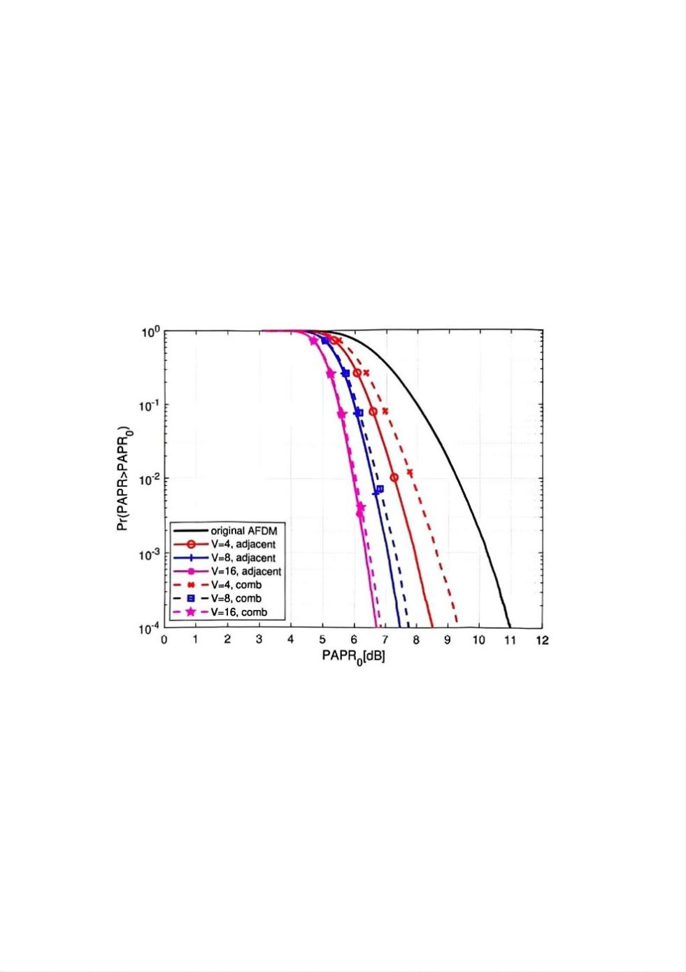
(a) Different $W$ and $Ω_{m}$ (b) Different $V$ and grouping patterns
Figure 11: PAPR performance of 16-QAM AFDM with GPS
As investigated in [3], by assigning different pre-chirp parameter $c_{2}$ to different subcarriers or groups of subcarriers, it is possible to generate multiple candidate signals. The transmitter can then select the signal with the lowest PAPR for transmission. This approach, referred to as grouped pre-chirp selection (GPS), effectively adjusts the phase alignment across subcarriers to minimize the high peaks in the time domain signal. Simulation results show that this technique can achieve significant PAPR reduction with only a marginal impact on bit error rate (BER) performance and a manageable increase in complexity.
Observation 5: The flexibility in selecting the pre-chirp parameter $c_{2}$ in AFDM can be leveraged to significantly reduce PAPR by optimizing the phase structure of the transmitted signal.
Proposal 6: RAN1 to study and specify the design of AFDM parameters (e.g.,$c_{1}$and $c_{2}$), low-complexity receiver algorithms for communication, sensing, and PAPR reduction, and their integration into a 6G-compatible system architecture, to enhance robustness against doubly-selective channels while targeting superior performance in sensing, high-mobility, and NTN scenarios.

3.3 Potential Impacts of AFDM on Existing MIMO Systems
Though AFDM is OFDM-like and compatible with OFDM to a large extent, the potential adoption of AFDM will still introduce new signal characteristics compared with those of conventional OFDM—which, in turn, affects the design of ISAC MIMO processing. In detail, the DAFT-domain structure of AFDM calls for in-depth research into several key aspects for ISAC applications, as outlined below.
1) Integrated Pilot Design, CSI Acquisition, and Target Sensing
AFDM employs DAFT modulation where each subcarrier spreads across the entire bandwidth. This property enables the estimation of the full channel response and the extraction of radar target parameters with only a single subcarrier’s pilot, leading to a dramatic reduction in pilot overhead compared with MIMO-OFDM over high mobility channels. Moreover, the DAFT-domain representation naturally separates multipath and Doppler components. Nevertheless, in MIMO systems, the design of sensing-communication multiplexed pilot patterns needs to jointly consider the antenna-domain and DAFT bin-domain. This unified pilot design is crucial to ensure that a single transmitted waveform can concurrently satisfy the stringent requirements of high-accuracy sensing and reliable communication.
2) Precoding and Beamforming for ISAC
In OFDM, precoding is typically performed per subcarrier using well-known approaches such as SVD-based or MMSE precoders; the transmit beam direction can be optimized independently for each subcarrier.
With AFDM, the DAFT-domain channel matrix contains significant inter-bin coupling due to multipath and Doppler impacts, so per-DAFT-bin SVD or zero-forcing precoding would suffer from severe inter-symbol interference. In addition, AFDM’s chirp-like basis causes the instantaneous phase of each subcarrier to sweep over time, so the effective beam direction varies across the symbol duration, complicating beam tracking and continuous target illumination for sensing. Consequently, for multi-antenna ISAC systems, it is imperative to investigate novel, low-complexity joint precoding and beamforming schemes in the DAFT domain. These schemes must not only mitigate inter-symbol interference but also generate highly directional and stable sensing beams to illuminate and track high-mobility targets efficiently.
3) Target Parameter Estimation and Joint Receiver Processing
In AFDM ISAC systems, target parameter extraction and signal detection need to be performed in the DAFT domain. For MIMO systems, this requires joint processing across both bins and antenna domains, presenting new advantages for high-resolution angle estimation. In typical ISAC scenarios dominated by LOS components, the AFDM channel typically exhibits strong sparsity in the DAFT domain, which inherently introduces new opportunities and challenges for high-resolution Angle of Arrival/Departure (AoA/AoD) estimation. The receiver needs to further leverage this sparsity to achieve extremely low-complexity multi-antenna sensing and detection. Recent studies [9] have demonstrated the effectiveness of using the DAFT sparsity by designing joint detection and decoding schemes with linear complexity. Such sparsity-driven approaches are also highly beneficial for designing low-complexity spatial-domain sensing algorithms. In the sparsening process, elements of the channel matrix that fall below a threshold are set to zero based on their correlation.
Proposal 7: RAN1 to investigate the implications of AFDM on MIMO integrated pilot design, target angle estimation, and joint receiver signal processing, etc., and to study low-complexity sensing techniques to ensure the efficient integration of AFDM with existing multi-antenna ISAC systems.

4. Conclusions
In this contribution, we presented our views on waveform candidates for 6G ISAC. Our proposals and observations are listed below.
Observation 1: To support long-range sensing and overcome self-interference, pulse-based waveforms require reference sequences with strict low-PAPR properties. However, operations such as time/frequency-domain zero-padding and truncation fundamentally disrupt the constant modulus property of ZC sequences, leading to severe PAPR degradation.
Observation 2: The structural compatibility of AFDM with OFDM-based systems, which arises from its implementation using existing IFFT/FFT blocks with low cost and flexible spectrum sharing capability with OFDM, combined with the inherent wideband nature of its individual chirp subcarriers, makes it a compelling candidate for ISAC. It offers the potential for high-resolution sensing with minimal hardware modification to the NR framework.
Observation 3: Compared with OFDM, AFDM can achieve a larger maximum unambiguous range with lower pilot overhead, thereby extending sensing range, improving target resolution capability and spectral efficiency.
Observation 4: In TDL-D channels, AFDM demonstrates a gain of nearly 2 dB over OFDM at 300 km/h and more than 4 dB at 500 km/h for a BER of 1e-3, with an even more pronounced advantage at the higher velocity of 1000 km/h.
Observation 5: The flexibility in selecting the pre-chirp parameter $c_{2}$ in AFDM can be leveraged to significantly reduce PAPR by optimizing the phase structure of the transmitted signal.
Proposal 1: The design of sensing RS and waveform enhancements for 6G ISAC shall take the reuse of existing communication RS (e.g., SRS, CSI-RS, PRS) as the baseline. RAN1 is encouraged to investigate targeted enhancements from both sequence parameter optimization and advanced signal/modulation designs to address sensing-specific requirements such as PAPR reduction, self-interference resilience, and range ambiguity.
Proposal 2: RAN1 to study the joint mathematical optimization of pulse-based waveform parameters, specifically the sequence root index, duty cycle, bandwidth occupancy, to theoretically bounds the worst-case PAPR while satisfying the high-power requirements of ISAC deployments.
Proposal 3: RAN1 to study and evaluate advanced PAPR reduction techniques for ISAC reference signals, including but not limited to non-linear frequency modulation (NLFM), enhanced modulation schemes (e.g., $π/2$-BPSK), and oversampled FMCW-like sequences.
Proposal 4: RAN1 to study additional waveform candidate(s) (e.g., AFDM) for 6G that remain structurally compatible with OFDM, enabling reuse of 5G NR/6G ecosystem components, while providing potential performance enhancements for ISAC and other challenging propagation scenarios.
Proposal 5: RAN1 to investigate AFDM as a candidate waveform for 6G ISAC systems, evaluating its parameter optimization towards high-efficiency sensing, high-mobility robustness, low PAPR, and backward compatibility with OFDM-based architectures.
Proposal 6: RAN1 to study and specify the design of AFDM parameters (e.g., $c_{1}$ and $c_{2}$), low-complexity receiver algorithms for communication, sensing, and PAPR reduction, and their integration into a 6G-compatible system architecture, to enhance robustness against doubly-selective channels while targeting superior performance in sensing, high-mobility, and NTN scenarios.
Proposal 7: RAN1 to investigate the implications of AFDM on MIMO integrated pilot design, target angle estimation, and joint receiver signal processing, etc., and to study low-complexity sensing techniques to ensure the efficient integration of AFDM with existing multi-antenna ISAC systems.

5. References
[1] RP-251881, “New SID: Study on 6G Radio,” NTT DOCOMO (Moderator).
[2] A. Bemani, N. Ksairi and M. Kountouris, "Integrated Sensing and Communications With Affine Frequency Division Multiplexing," in IEEE Wireless Communications Letters, vol. 13, no. 5, pp. 1255-1259, May 2024.
[3] H. Yuan, Y. Xu, X. Guo, et al., "PAPR Reduction With Pre-Chirp Selection for Affine Frequency Division Multiplexing," in IEEE Wireless Communications Letters, vol. 14, no. 3, pp. 736-740, March 2025.
[4] R1-2602759, "Overall views on 6G ISAC," ZTE Corporation, Beijing Digital Nebula, Sanechips.
[5] R1-2603081, "Discussion on Waveform and frame structure for ISAC," NTT DOCOMO, INC.
[6] R1-2603032, "Sensing waveforms for 6GR air interface," Qualcomm Incorporated.
[7] V. Savaux, "Special Cases of DFT-Based Modulation and Demodulation for Affine Frequency Division Multiplexing," in IEEE Transactions on Communications, vol. 72, no. 12, pp. 7627-7638, Dec. 2024.
[8] R. Y. Bir, A. Ammar Boudjelal and H. Arslan, "On the Orthogonal Coexistence of AFDM and OFDM for Joint Sensing and Communication," in IEEE Open Journal of the Communications Society, vol. 6, pp. 10010-10022, 2025, doi: 10.1109/OJCOMS.2025.3638461.
[9] Q. Luo et al., "Joint Sparse Graph for Enhanced MIMO-AFDM Receiver Design," in IEEE Transactions on Wireless Communications, doi: 10.1109/TWC.2025.3603012.

